Cloud Computing Lab 6

Name : Manohar M Hegde
SRN : PES1UG23CS350
Section : F

SS1:
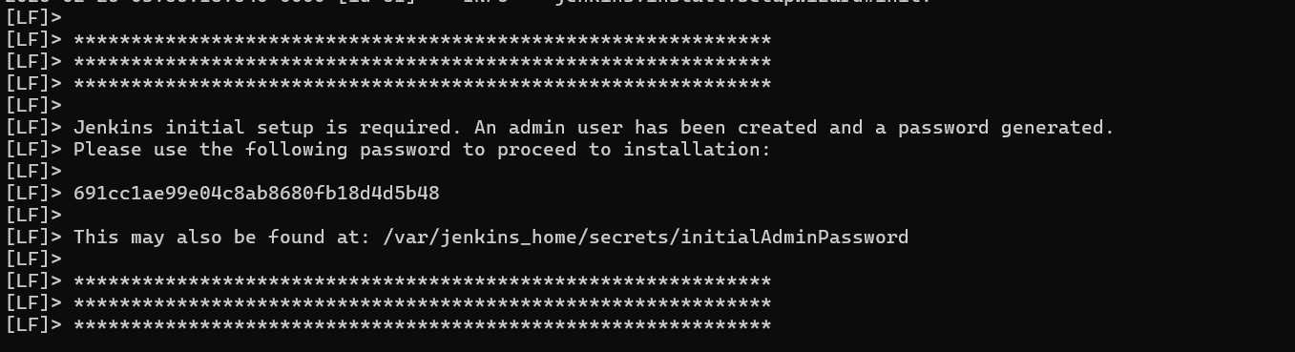
SS2:
